|  |  |
| --- | --- |
| **Date** | **19 JUNE 2025** |
| **Team ID** | **LTVIP2025TMID30830** |
| **Project Name** | **Lease Management** |
| **Maximum Marks** |  |

**Object:**

**What Is an Object?**

Salesforce objects are database tables that permit you to store data that is specific to an organization. What are the types of Salesforce objects

**. Salesforce objects are of two types:**

1. Standard Objects: Standard objects are the kind of objects that are provided by salesforce.com such as users, contracts, reports, dashboards, etc.
2. Custom Objects: Custom objects are those objects that are created by users. They supply information that is unique and essential to their organization. They are the heart of any application and provide a structure for sharing data.

**.** **To Navigate to Setup page:**

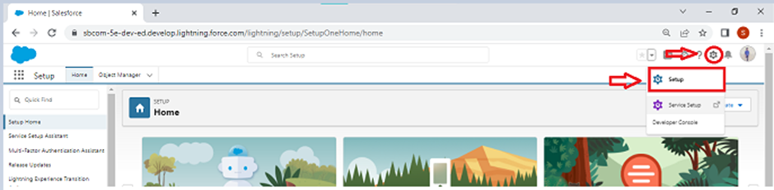

**To create an object:**

1. From the setup page ? Click on Object Manager ? Click on Create ? Click on Custom Object.

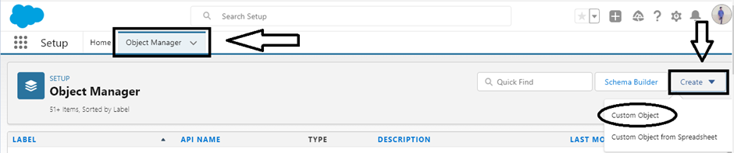

2. On Custom object defining page:

3. Enter the label name, plural label name, click on Allow reports, Allow search.

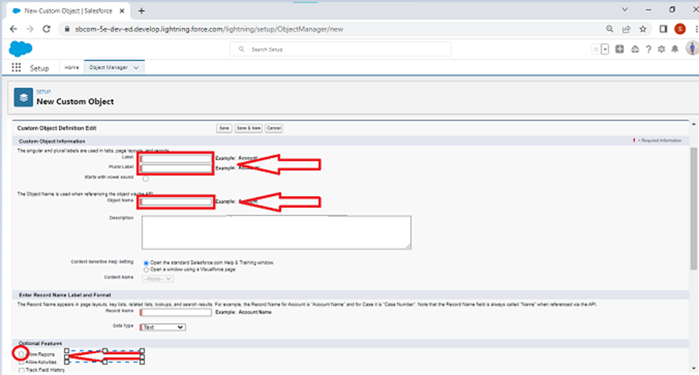

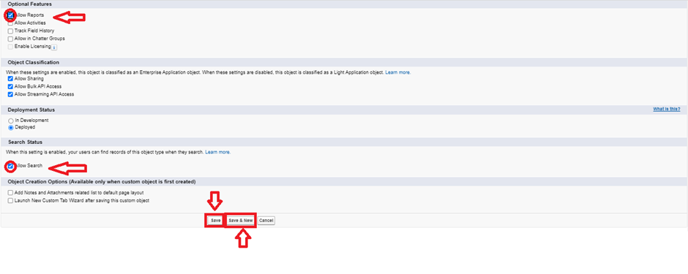

1. Click on Save.

**1.Create Property Object:**

**To create an object:**

1. From the setup page >> Click on Object Manager >> Click on Create >> Click on Custom Object.
2. Enter the label name>> property
3. Plural label name>> property
4. Enter Record Name Label and Format

* Record Name >>property Name
* Data Type >> Text

1. Click on Allow reports and Track Field History,Allow Activities
2. Allow search >> Save.

**2.Create Tenant Object:**

**To create an object:**

1. From the setup page >> Click on Object Manager >>Click on Create >> Click on Custom Object.
2. Enter the label name>> Tenant
3. Plural label name>> Tenants
4. Enter Record Name Label and Format

* Record Name >> Tenant Name
* Data Type >> Text

1. Click on Allow reports and Track Field History,Allow Activities
2. Allow search >> Save.

**3.Create Payment Object:**

**To create an object:**

1.From the setup page >> Click on Object Manager >> Click on Create >> Click on Custom Object

1. Enter the label name>> Payment for tenanat
2. Plural label name>> Payment
3. Enter Record Name Label and Format

* Record Name >> Payment Name
* Data Type >> Text

1. Click on Allow reports and Track Field History,Allow Activities

Allow search >> Save.

**4.Create Lease Object:**

**To create an object:**

1. From the setup page >> Click on Object Manager >> Click on Create >> Click on Custom Object.
2. Enter the label name>> lease
3. Plural label name>> lease
4. Enter Record Name Label and Format

* Record Name >> lease Name
* Data Type >> Text

1. Click on Allow reports and Track Field History,Allow Activities
2. Allow search >> Save.